Steps to configure XAMPP Web server using PHP to host images:

1. Download and install XAMPP server: <https://www.apachefriends.org/index.html>
2. By default ports used for Apache webserver: 80 and 443 and also ports used for Tomcat server 8080 and 8443 are not allowed on home networks/routers. You need to override your router network configuration/redirect network traffic for your domain host towards alternative ports and also change the ports in the XAMPP server configuration. The following steps address this.
3. Execute the command: ipconfig /all for Windows or ifconfig /all for Linux or other corresponding commands.
   1. 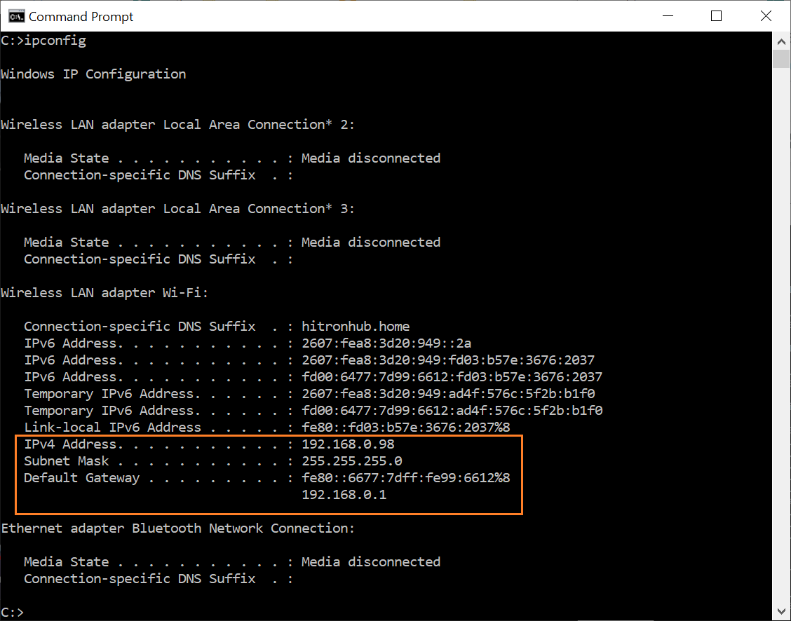
4. Get Wifi networks or the active network configuration from step 3.
5. For Windows: navigate to Control Panel -> Network and Sharing -> Change Adapter Settings
6. From Change Adapter settings -> select Wifi or the active network settings that your computer uses
7. Right-click and open properties and add an entry of IPV4, Subnet mask, and Default gateway, and also DNS Server IP from the above command prompt.
8. Click Save.
9. Now go to Control Panel -> Program and Features -> Add Windows features and install Internet Information Services (IIS)
10. Now that we created IPV4 IP address entries, go to your router address and add Port Forwarding for 80,443, 8080, and 8443 ports to alternative ones. Normally in the case of the CMU network, we do not need to forward ports. We just provide redirecting ports (suppose we want all port 80 to go to myhostname:8088, then we just update httpd.conf files from the XAMPP folder installed on the Linux server/machine from VIM/nano editor.
11. For Windows, navigate to the XAMPP folder and go to the “apache” folder -> “conf” folder, and open httpd.conf to edit: make “Listen 80” to “Listen 8088”. Likewise, change “ServerName localhost:80” to “ServerName localhost:8088”
12. We also need to update the virtual host configuration so go to the “apache” folder -? “conf” folder and update “NameVirtualHost *:80” to “NameVirtualHost *:8088”
13. Now launch the XAMPP panel from Start -> Programs that we just installed in step 1.
14. Click “Config “ button and from the Config window, click “Service and Port Settings” update as follows for Apache and TomCat:
    1. Graphical user interface, application, Word

       Description automatically generated
    2. Graphical user interface, application

       Description automatically generated
15. Click save until all settings are saved and all windows are closed except the Main XAMPP panel.
16. On the XAMPP panel, Click on Start “Apache”, “MySQL” and click on “TomCat”
17. If you do run into a problem with Tomcat, you need to install JDK and JRE.
18. Add following entries to Environment variables from Control Panel – System and Settings -> Change Environment Variables as follows
    1. A picture containing graphical user interface

       Description automatically generated
    2. Now add environment variables for JAVA:
    3. 
    4. Add following entry to System Variable -> PATH -> Edit and append or add to JAVA_HOME variable paths - %JAVA_HOME%\bin;%JAVA_HOME%\lib;%JAVA_HOME%\lib\tools.jar;%JAVA_HOME%\bin;%JAVA_HOME%\jre\bin;
19. Click save and now Stop and Start “Apache”, “MYSQL”, “Tomcat”.
20. Now ideally all should be green and running. You can verify by clicking on the Admin button next to each of the services.
21. Apache: <http://localhost:8088/dashboard/>
22. Tomcat: <http://localhost:8181/>
23. MySQL: <http://localhost:8088/phpmyadmin/>
24. Graphical user interface, text, application, email

    Description automatically generated
25. Once all of the above are running, now we need to map the local IP address to a DNS hostname of our choice. For that: decide on a DNS hostname and add a DNS Hostname entry in your router if you are using a Home network.
26. In my case, I used imageserver2021.ddns.net. So now we need to map the IP address to the DNS hostname so now
27. Navigate to noip.com ad register and you can create up to 3 hostnames.
28. Now add the IP address we noted from step 3 and the hostname you added in your home network or the one you want to map an IP address to a hostname (Select DNS as an option so we are mapping IP address to a hostname).
29. Click Save and wait for 5 minutes for the changes to configure.
30. Now navigate to the hostname for example <https://imageserver2021.ddns.net/>

1. And here you can see your Apache server (since we mapped Apache server port in httpd.conf a virtual host config.
2. The purpose of creating above is to host a bunch of images: <http://www.nux.ro/oldblog/archive/2012/10/Instant_image_gallery_with_Apache_s_mod_autoindex_and_fancybox.html>
3. Within *xampp folder -> htdocs -> fancybox -> .htaccess* add Allow CORS header specification as follows:
   1. Header set Access-Control-Allow-Origin *
4. Once the above steps are complete: we can see <https://imageserver2021.ddns.net/fancybox/temp3_300_3/0001_0001/>
5. Table

   Description automatically generated
6. WE need to purchase a Public IP to share the above link publicly. Home network routers used to allow the public IP addresses to be mapped to DNS hostnames. But now it is not possible unless we explicitly create a public IP and purchase it. Hence <https://imageserver2021.ddns.net/> will not be accessible from the internet as per my tests. Even if it does allow, it asks for a router password which is not a safe direction to achieve setting up a website at home.